Dashboard Design

Date | 26 JUN 2025
Team ID | PNT2022TMIDxxxxxx
Project Name | Food Production Visualization
Maximum Marks | 5 Marks

Designing an effective dashboard in Power BI requires clarity, relevance, and interactivity. In this project, the dashboard was developed to visualize global food production data in a user-friendly and insightful manner. The design ensures that users can easily explore the dataset, draw conclusions, and identify patterns using various chart types and filters.

Activity 1: Interactive and Visually Appealing Dashboard
To ensure a well-structured and visually engaging dashboard, the following design principles were applied:
- Clear and Intuitive Layout
Visuals were organized logically with summary metrics on top, comparative visuals in the center, and filters on the left for easy access.
- Use of Appropriate Visualizations
Different chart types were selected based on the data type and use-case, such as column charts for comparisons and area charts for trends.
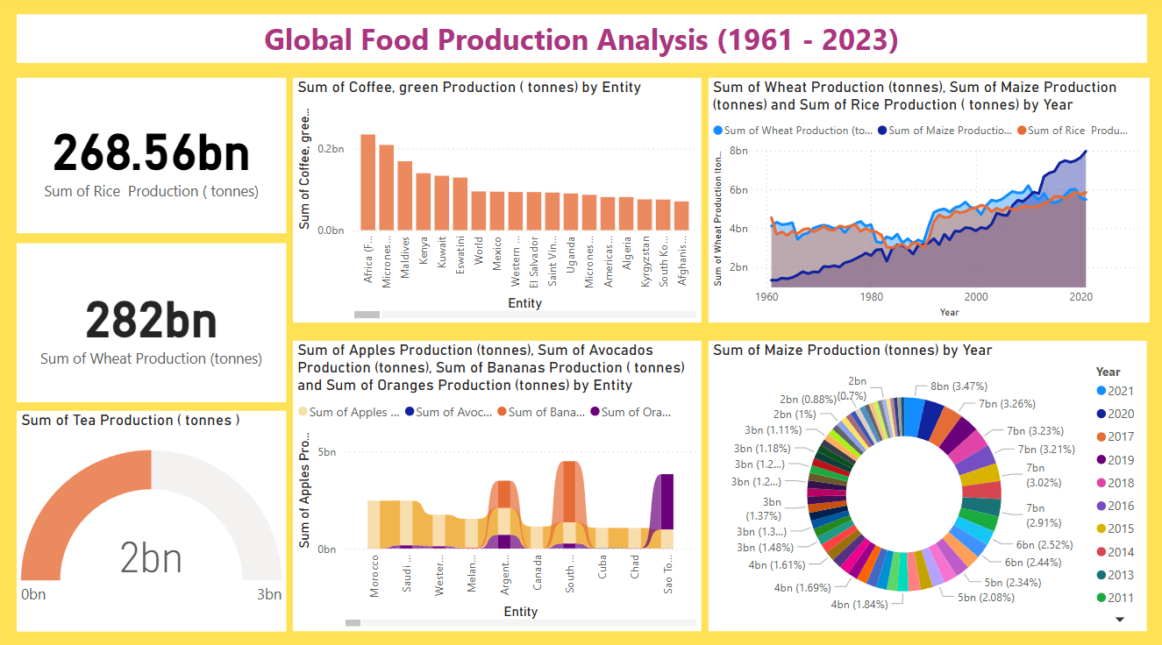
- Color and Theming
A consistent theme using green and blue shades was used to reflect agricultural relevance and maintain readability.
- Interactive Filters and Slicers
Year, country, and crop filters were added to allow users to customize their analysis based on interest.
- Drill-Down Capabilities
The ribbon and funnel charts were used to allow users to navigate from overall production to crop-specific and country-specific data.
- Responsive Design
The dashboard layout was optimized for various screen sizes, ensuring usability during presentations and reviews.
- Custom Visuals and Icons
Simple icons and tooltips were used to enhance the interpretability of visuals.
- Use of Infographics
Donut and gauge charts were used to summarize key data points in a visual storytelling format.

